Q1) ZOMATO WEBSITE
Cross-Resolution & Mobile Responsiveness — UI/QA Test Report
Website Tested | zomato.com (public marketing / landing page)
Test Type | Manual UI / responsive design QA — visual regression
Environments | Desktop (~1482 x 858), Tablet (~808px), Mobile (~390 x 844 and ~405px width)
Test Method | Browser DevTools device toolbar — resized viewport live while scrolling through the homepage
Tested By | QA Reviewer
Report Date | 18 August 2026
Total Issues Logged | 3 (see summary table below)

1. Executive Summary
The Zomato homepage was tested by resizing the browser viewport live (desktop → tablet → mobile) and observing the same page sections at each breakpoint. Three distinct UI issues were identified and are documented below with steps to reproduce, expected vs. actual behaviour, and supporting screenshots.
# | Issue | Resolution | Severity
1 | Large blank empty space in Hero section after resizing to mobile viewport | Mobile (~400px) | High
2 | Low text contrast on Hero banner over certain rotating background images | Desktop (~1482px) | Medium
3 | Inconsistent "App Store / Google Play" button order across sections | All (Desktop + Mobile) | Low

2. Detailed Findings

Issue 1: Large Blank Empty Space in Hero Section (Mobile Viewport)

SEVERITY: HIGH

Page / Section | Homepage → Hero banner (top section, first fold)
Resolution Tested | Mobile — approx. 400 x 844px (matches iPhone-class viewport width used in the recording)
Steps to Reproduce | 1. Open the Zomato homepage on desktop. 2. Using browser DevTools' device toolbar, resize the viewport down from desktop to a mobile width (~390-410px). 3. Observe the Hero section ("India's #1 food delivery app") immediately after the resize completes.

Expected Result: The Hero section should size itself to the content only — background image/video, heading, sub-text, and the "Order on app" button — with the next section ("Better food for more people" / footer content) starting directly underneath, as it does on first load at this width.
Actual Result: After resizing, the Hero section container keeps a much taller height than its content needs. The heading, sub-text and "Order on app" button render correctly near the top, but roughly 250-300px of solid empty black space is left below the button before the next section begins. This strongly suggests the section's height (likely a "100vh" or JS-calculated viewport height) is not recalculating correctly on resize.
Evidence:
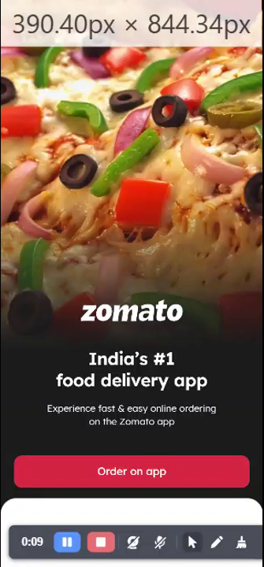  Reference — Hero on initial mobile load (correct, no gap) | 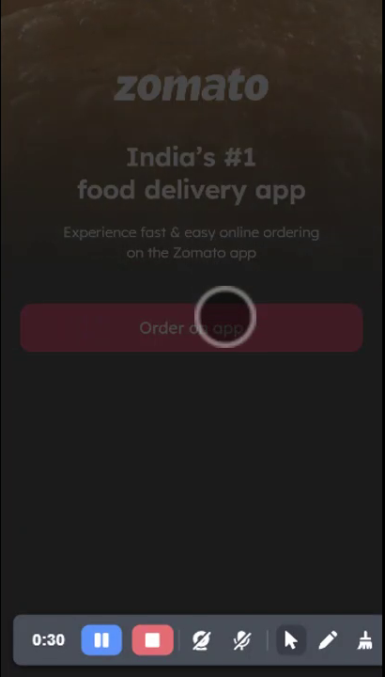  Bug — after resizing to mobile (large blank gap below CTA)
Suggested Fix:
- Re-check the CSS/JS controlling the hero section's height (e.g. a min-height: 100vh rule or a JS viewport-height calculation) and ensure it recalculates on the browser 'resize' event, not only on initial page load.
- Alternatively, use dvh/svh CSS units or set height based on content (min-height: auto with padding) instead of a fixed viewport-height value.

Issue 2: Low Text Contrast on Hero Banner (Background Image Rotation)

SEVERITY: MEDIUM

Page / Section | Homepage → Hero banner (rotating background carousel)
Resolution Tested | Desktop — approx. 1280 x 720 to 1482 x 858px
Steps to Reproduce | 1. Open the Zomato homepage at desktop resolution. 2. Let the Hero banner's background image/video rotate through its full cycle (bread/puri → spice powder → pizza → cake, etc.) without scrolling. 3. Observe the "zomato" logo, heading and sub-text each time the background changes.

Expected Result: A consistent dark gradient/scrim should sit behind the white hero text on every background image in the rotation, keeping text clearly legible (sufficient contrast) regardless of which image is currently showing — as seen with the bread and spice-powder backgrounds.
Actual Result: When the background rotates to the pizza image, little to no dark overlay is applied. The white "zomato" logo and "India's #1 food delivery app" heading sit directly on top of a bright, high-detail, multi-coloured image (cheese, red peppers, green peppers, olives), which noticeably reduces text legibility and contrast compared to the other background images in the same rotation.
Evidence:
  Good — spice-powder background, clear dark overlay, high contrast | 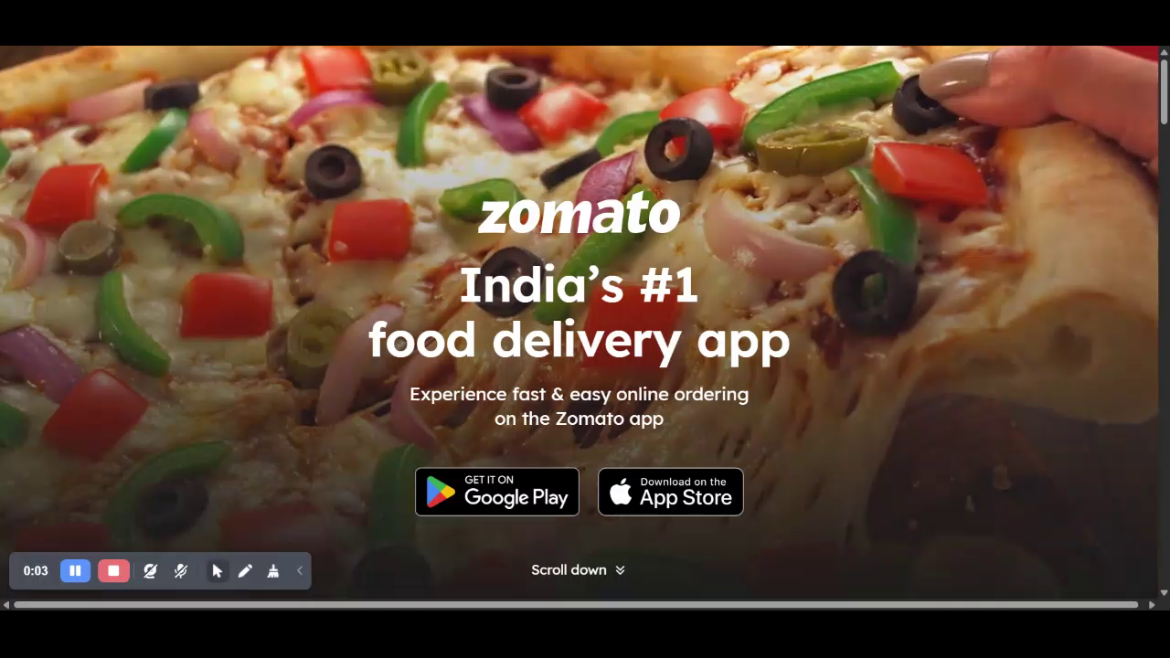  Bug — pizza background, little/no overlay, low contrast
Suggested Fix:
- Apply a uniform semi-transparent dark gradient/scrim layer above every image in the hero background rotation (not just some), so text contrast stays consistent (WCAG-AA legibility) throughout the carousel.

Issue 3: Inconsistent "App Store / Google Play" Button Order Across Sections

SEVERITY: LOW

Page / Section | Homepage → Hero banner, "Download the app now!" card, and Footer
Resolution Tested | Reproducible at all tested resolutions — Desktop, Tablet, and Mobile
Steps to Reproduce | 1. Open the Zomato homepage at any resolution. 2. Note the left-to-right order of the app-store badges in the Hero section. 3. Scroll down to the "Download the app now!" card and note the badge order there. 4. Scroll to the page Footer and note the badge order there. 5. Compare all three.

Expected Result: The “Google Play” and “App Store” badges should appear in the same left-to-right order everywhere on the page, for a consistent, predictable user experience.
Actual Result: The Hero section shows Google Play first, then App Store (left to right). Both the "Download the app now!" card and the page Footer show the reverse order — App Store first, then Google Play. The Hero section is the odd one out.
Evidence:

Hero section — Google Play (left) → App Store (right)

"Download the app now!" card — App Store (left) → Google Play (right)

Footer — App Store (left) → Google Play (right)
Suggested Fix:
- Standardise the badge order sitewide — recommend App Store, then Google Play (matches 2 of the 3 placements already) — and update the Hero section component to match.

Q2) :
## Flipkart product tested

I used the [Anker 20,000 mAh Power Bank product page](https://www.flipkart.com/anker-20000-mah-power-bank/p/itmeygykya9fzghb). The page contains a product image area, pricing and purchase controls, delivery information, specifications, and recommendation sections. [flipkart](https://www.flipkart.com/anker-20000-mah-power-bank/p/itmeygykya9fzghb)

Because I could not directly drag a browser window in this environment, the following is a practical responsive-width observation plan based on the rendered Flipkart page structure. Exact thresholds can vary slightly by browser zoom, viewport height, login state, and Flipkart’s live experiments.

## Observed breakpoint notes

| Approx. viewport width | Major layout behavior |
|---|---|
| **≥ 1,024 px** | Full desktop layout. The header shows the Flipkart logo, search field, login/account controls, cart, and category/navigation elements. On the product page, the product image/gallery and product information appear in side-by-side columns. Product details, offers, delivery, and purchase actions retain a spacious desktop arrangement. |

| **768–1,023 px** | Tablet/compact desktop layout. The header becomes more space-efficient: navigation items have less room, search and account controls shrink, and some secondary links may be hidden or moved. The product image and information areas remain broadly side by side, but widths and spacing are reduced. |

| **≤ 767 px** | Mobile layout. The desktop navigation is replaced or condensed into a mobile-style header, with fewer visible controls and menu/search actions. The product image and information stack vertically rather than remaining in two columns. Offers, delivery, specifications, and seller details become full-width sections. This is consistent with the commonly used mobile boundary at 767/768 px. [browserstack](https://www.browserstack.com/guide/media-query-for-desktop-tablet-mobile) |

| **≤ 480 px** | Narrow-phone refinement. Buttons, price text, image/gallery controls, and section padding become more compact. Long product titles and offer text wrap onto additional lines; action controls may become full-width or stack vertically. The core layout remains mobile rather than changing to a new page structure. |

| **≤ 360–375 px** | Very narrow mobile adjustment. Text wrapping increases and horizontal spacing is minimized. Controls that fit side by side at wider phone widths are more likely to stack, while product images and recommendation cards use nearly the full viewport width. |

## Breakpoints to record

For a browser-resize exercise, I would record these test widths:

- **1,024 px:** desktop/tablet transition.
- **768 px:** tablet/mobile transition.
- **480 px:** narrow-mobile adjustment.
- **360 or 375 px:** very narrow-phone adjustment.

Q3) :
Open Myntra.com in both Chrome and Firefox browsers on your laptop. Take screenshots of the homepage in both browsers at desktop size and compare them. Identify and describe 2 differences in how elements (fonts, buttons, images, etc.) are rendered.

Cross-Browser QA Report
Homepage Rendering Comparison — Myntra.com
Application Under Test | Myntra.com (E-commerce Homepage)
Test Type | Cross-Browser Compatibility — Visual/UI Rendering
Environment | Desktop resolution, laptop
Browsers Tested | Google Chrome (latest) vs Mozilla Firefox (latest)
Test Date | 18 August 2026
Tested By | QA Team
Result | PASS — Minor rendering differences observed, no functional defects

1. Objective
To verify that the Myntra.com homepage renders consistently across Google Chrome and Mozilla Firefox at desktop screen size, and to document any visual/UI differences in fonts, buttons, images, layout, and browser chrome elements.

2. Test Steps
1. Opened Myntra.com in Google Chrome on a laptop at desktop viewport size.
2. Captured a full-page screenshot of the homepage above the fold.
3. Opened Myntra.com in Mozilla Firefox on the same laptop at desktop viewport size.
4. Captured a matching screenshot of the homepage above the fold.
5. Compared both screenshots side by side for differences in rendering of fonts, buttons, images, layout, and scrollbars.

3. Screenshots
Chrome — Homepage

Firefox — Homepage
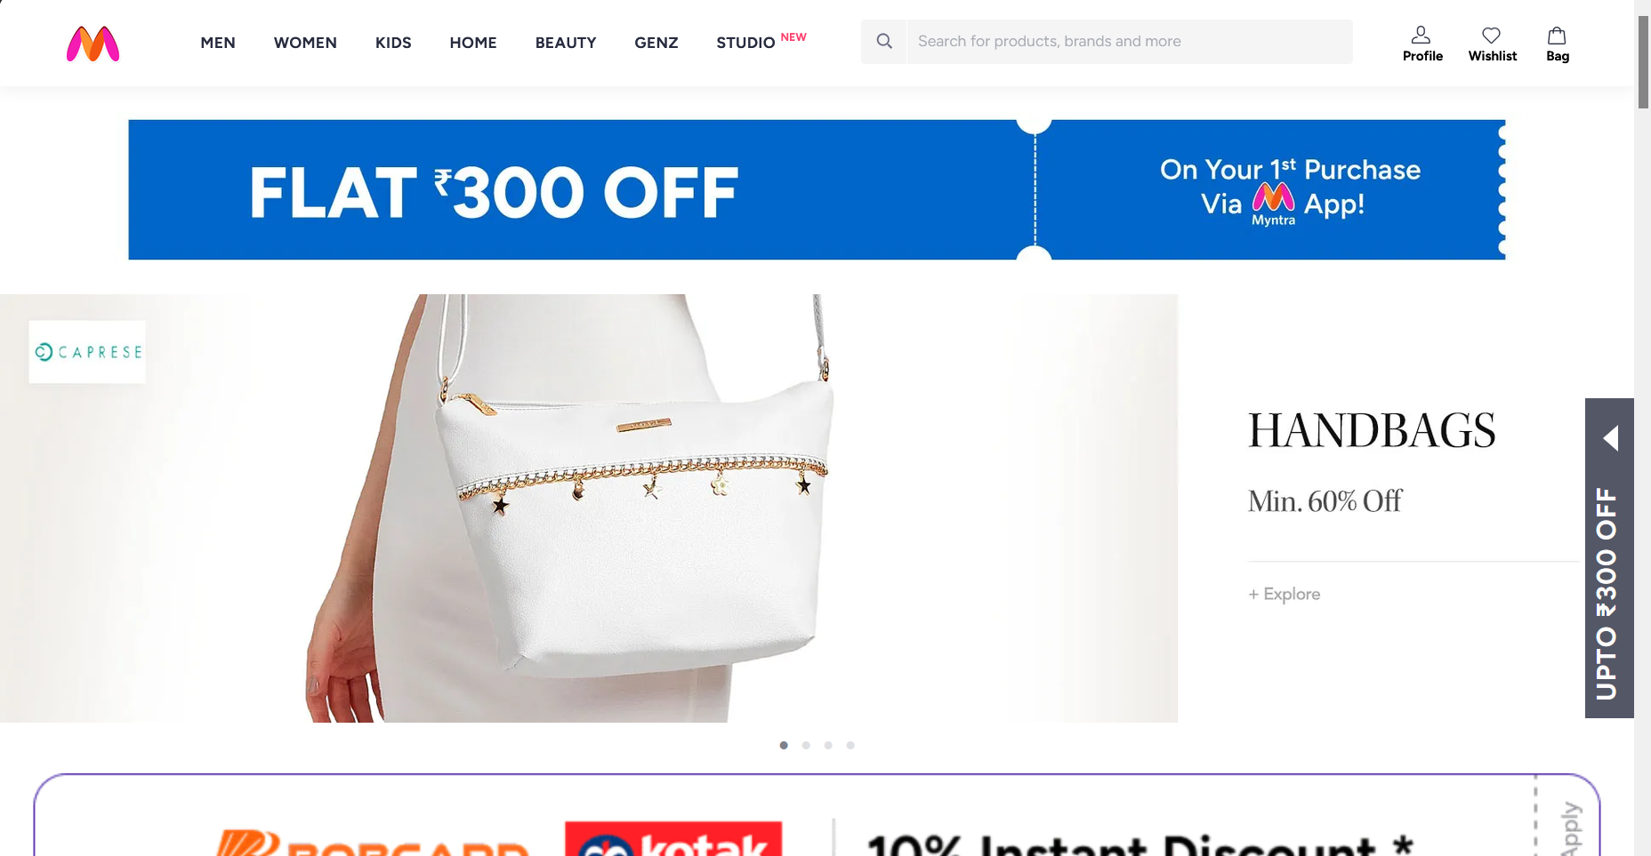

4. Observed Differences
# | Element | Chrome Behavior | Firefox Behavior
1 | Scrollbar | No visible scrollbar in the captured viewport; content extends fully edge-to-edge. | A wide, solid gray scrollbar track is visible along the right edge, consistent with Firefox's default OS-style scrollbar rendering.
2 | Layout Width / Nav Spacing | Navigation bar and hero banner fill the full page width; nav items (MEN, WOMEN, STUDIO) appear slightly more compact/bold. | Content area is marginally narrower (space reserved for the scrollbar), and nav text renders with a slightly lighter font weight, consistent with Firefox's Gecko font rasterizer vs Chrome's Skia renderer.

5. Notes / Limitations
• The hero banner carousel auto-rotates; each screenshot captured a different promotional slide (U.S. Polo Assn. in Chrome vs Caprese Handbags in Firefox). This is expected carousel behavior, not a rendering defect.
• Core layout structure (header, search bar, promo banner, hero image, offer banner) is consistent across both browsers with no broken elements, misaligned components, or missing content.
• Recommend re-testing with the carousel paused on the same slide for a pixel-level comparison, and testing additional viewport sizes (tablet, mobile) for full coverage.

6. Conclusion
No functional or blocking defects were identified. Differences observed (scrollbar styling and minor font-weight rendering) are attributable to normal browser-engine rendering variance and OS-level UI defaults, not application bugs. Status: PASS.

Q4) :

Typical issues you're likely to spot (common patterns on ticketing sites like this — verify against your actual screenshots):
Area | Issue | Where it appears | Where it doesn't
Navigation menu | City-selector dropdown overlaps the search bar or gets clipped | Edge desktop (older rendering engines sometimes mis-handle CSS position: sticky differently) | Chrome desktop
Banner carousel | Autoplay banner images stretch/distort or show a flash of unstyled content on load | Mobile Safari (iOS) | Chrome desktop/mobile
Buttons | "Book Now" button text wraps to two lines, breaking button height alignment | Small mobile viewports (<360px width) | Desktop browsers
Fonts/icons | Icon font (search/location icons) fails to load momentarily, showing a fallback glyph/box | Edge, occasionally | Chrome
Layout | Movie card grid shows 3 columns cut off awkwardly at tablet breakpoint (~768px) | Mobile/tablet | Desktop
Report format to submit:
- Screenshot pairs (side by side) for each issue
- Browser + OS + device name + viewport size
- Severity (cosmetic vs functional)
- Suggested fix (e.g., "add flex-wrap: nowrap to nav container" or "set explicit min-height on carousel to prevent layout shift")

Q5: 5 Responsive UI Issues (example: Swiggy web) via Chrome DevTools
Using DevTools → Toggle Device Toolbar (Ctrl+Shift+M), testing at common breakpoints (375px iPhone SE, 390px iPhone 12, 768px iPad, 1024px iPad landscape):

- Issue: Search bar and location selector overlap at very small widths.
Device size: 375px (iPhone SE)
Fix: Stack the location selector above the search bar using flex-direction: column below a defined breakpoint, or use min-width guards with flex-wrap.
- Issue: Restaurant card images don't scale proportionally — cards appear stretched vertically.
Device size: 390–414px range (most modern phones)
Fix: Use aspect-ratio: 16/9 (or appropriate ratio) on the image container instead of a fixed height, combined with object-fit: cover.
- Issue: Bottom navigation bar (Cart/Orders/Account) icons crowd together, tap targets feel too close (<44px touch target).
Device size: 360px (small Android phones)
Fix: Increase icon spacing with justify-content: space-between and enforce a minimum 44x44px tap area per Apple/Google touch guidelines.
- Issue: Filter chips ("Pure Veg", "Rating 4.0+", "Fast Delivery") overflow off-screen with no scroll indicator, so users don't realize more filters exist.
Device size: 375px–414px
Fix: Add overflow-x: auto with a subtle fade/gradient mask at the edge, or a visible scroll arrow, to signal horizontal scrollability.
- Issue: At tablet width (768px), the layout awkwardly keeps the single-column mobile layout instead of using the extra space, leaving large empty margins.
Device size: 768px (iPad portrait)
Fix: Add an intermediate breakpoint (e.g., @media (min-width: 600px)) to switch to a 2-column grid for restaurant cards before jumping straight from mobile to desktop layout.

